Environmental Modeling
Exercise: Fire in the Forest

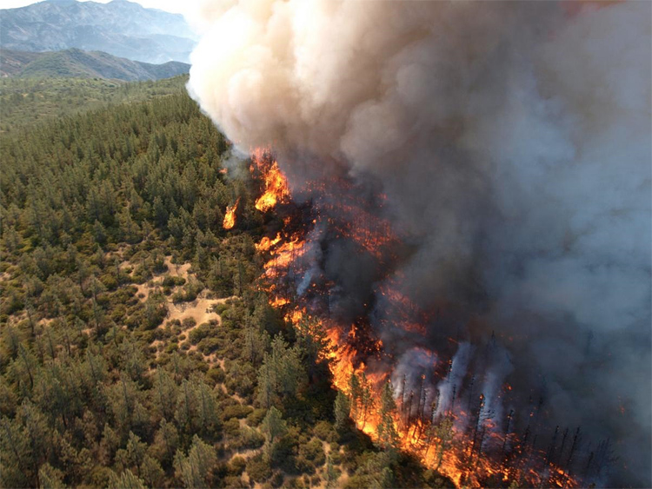

When a model is based on randomness, it is not possible to trust in the result of a single simulation because different simulations will certainly produce different outcomes. In this case, it is necessary to run more than one simulation to estimate the average result and its stability. The fire-in-the-forest model is one example. As the initial state of the cells is randomly chosen, running the simulation again can produce different outcomes.

Investigate the fire-in-the-forest model and analyse the results related to the duration of the fire, the number of cells burned, and the number of forest cells that survive at the end of the simulations. Repeat 5 simulations with different percentages of initial forest ranging from 0% to 100% to analyse the following scenarios:

- The original model (forest-fire-random.lua).
- Using a Moore neighborhood (8 neighbors), instead of von Neumann.
- A burning cell becomes burned after two time steps, instead of only one.
- Changing the space to 100x100 cells. Compare this result with the others by assuming that four cells in this case occupy the same space of one cell in the original model, which means that the overall area is the same.
- There is a probability of 60% that a cell will burn if it finds a burning neighbor, adding a second random component to the model.

The scenarios two to five are independent changes of the original model. Deliver the source code as well as a report comparing the different results. For further help see “Percolation on a 2D lattice – a Monte Carlo computational analysis”, at http://cantab.jkut.com/Percolation%20on%20a%202D%20lattice.pdf

In fact, if you run forest-fire-random.lua twice you will get completely different results. By internally calling the Lua function "os.time( )", the random number generator of TerraME uses the computer's current time as seed. If you need to reproduce the outcomes of one model run, then you should use the same seed in both experiments. For this, insert the command "rand = Random{ seed = SEED }" in the beginning of the source code. SEED can be any number. It will be used as the seed for the sequence of random numbers generated by TerraME.

